**Weebly Eportfolio for MSE Students**

1. Go to <https://education.weebly.com/> to register for a new website. First, sign-up for a free website. Weebly allows you to have up to 10 free websites. Look to the left menu item. Use your csm or personal account. I recommend using gMail if you have it.

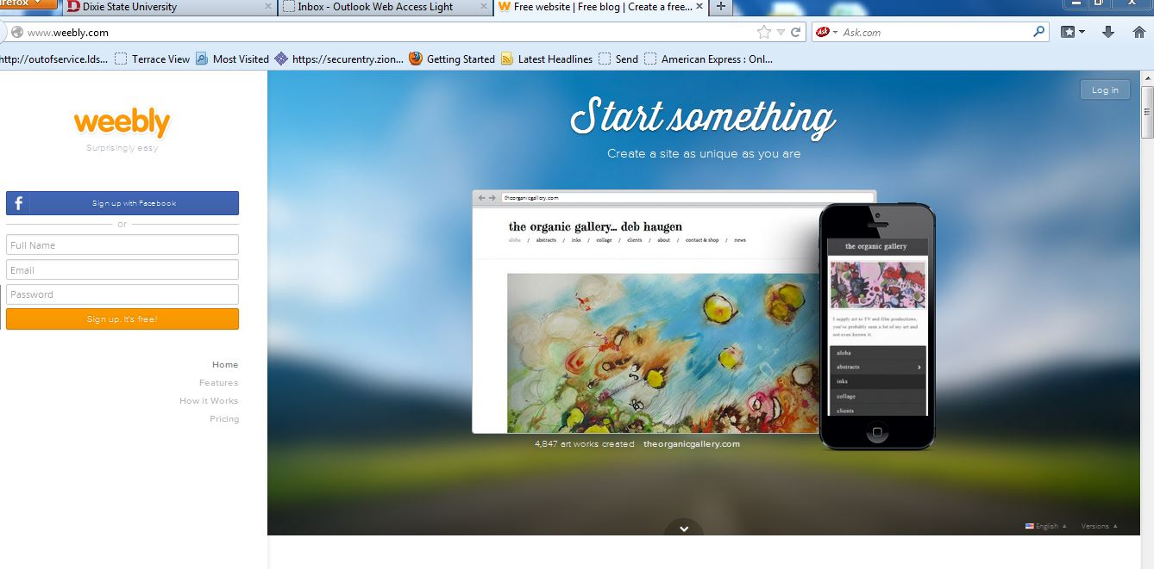

2. Choose your theme. You can always change this later. Remember to select a professional theme for this will be your eportfolio you may wish to send to cooperating teachers and principals. You can also change the picture and sometimes colors. Select a template/theme that allows you to see most of the pages on the menu bar.

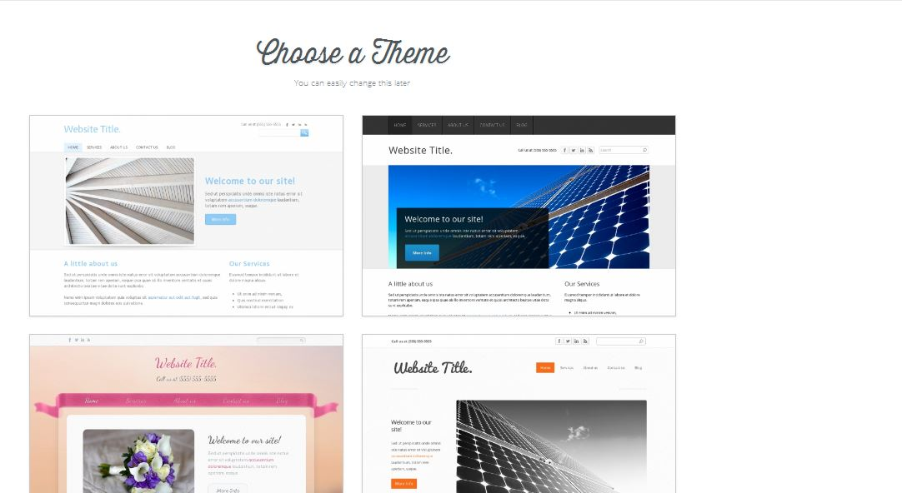

3. Select you url address. I suggest using your last name, add eportfolio. This will create your url address that will end in .weebly.com for the free site. **Make sure you select "Use a subdomain of Weebly.com.**  Select continue. You can watch a free tutorial site, if needed. Then go to "Build my site." So your URL will look like this: http://nameeportoflio.weebly.com.

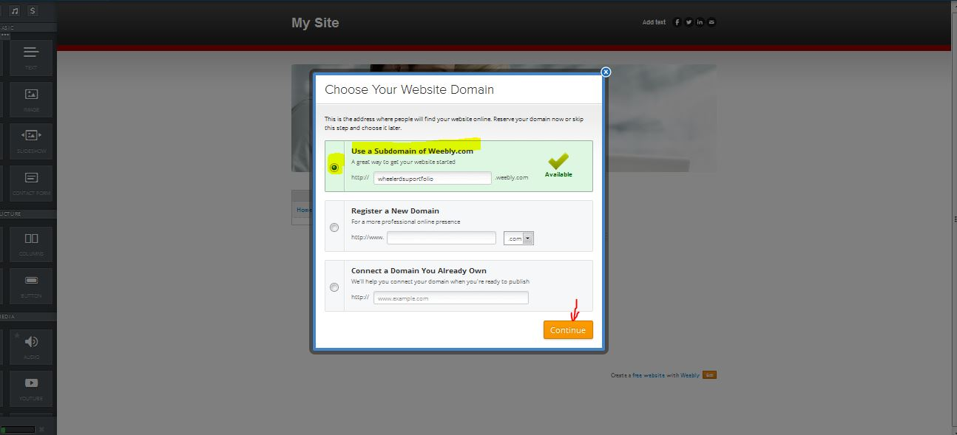

4. First, put your name at the top. Notice the red arrow at the top. You can also change the picture- see the red arrow next to the picture. The blue arrow shows where my menu items or pages will be. To the left is the tool bar that will allow me to add things to my website. When using the free Weebly, there might be some limits to the tools you to which you have access.

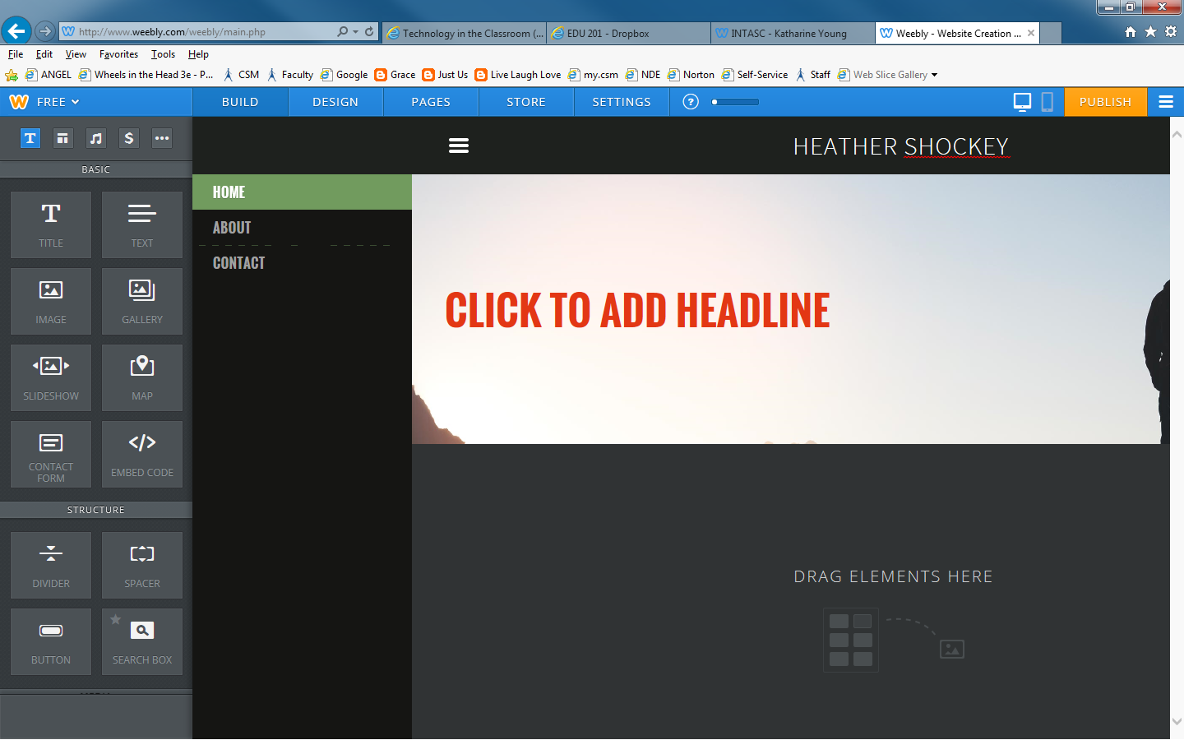

5. You can add an image from your computer. You can use images you have saved or go to Google images and find an image you like, save it on your computer, and then upload it to your website.

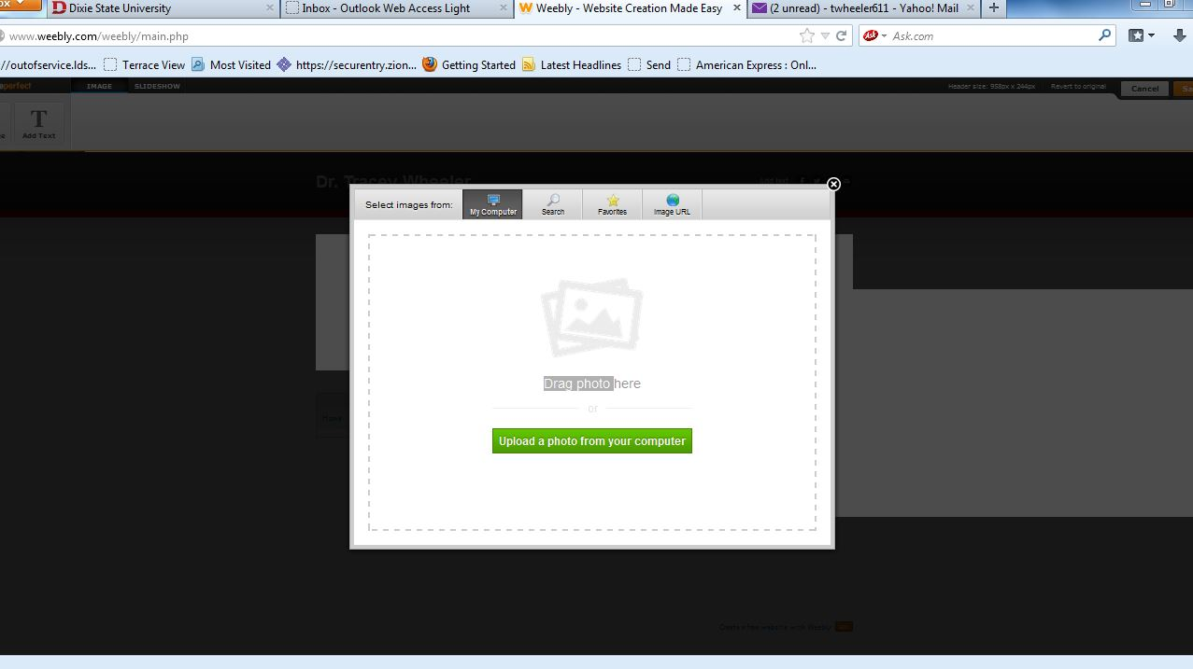

6. Next, you are going to add pages/ menu items to the eportfolio. If you look in the upper left on the blue bar, you will see the red arrow. Click on pages.

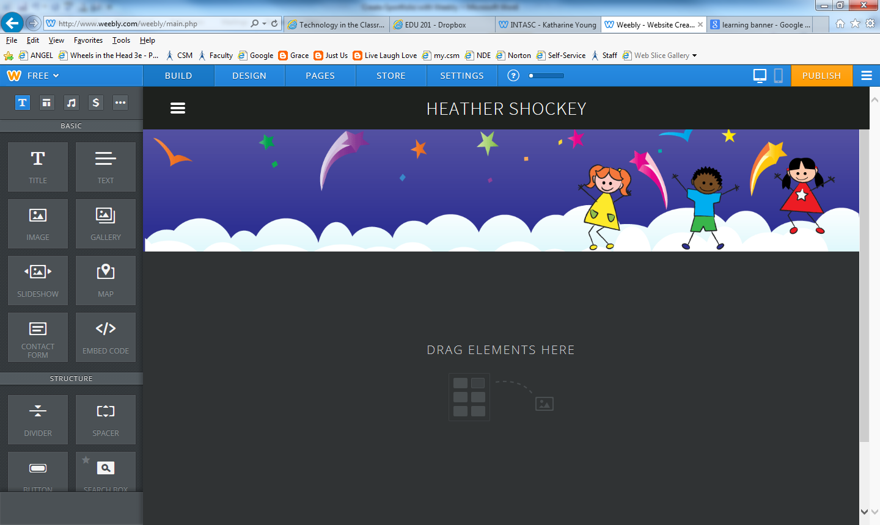

7. Add new pages and titles

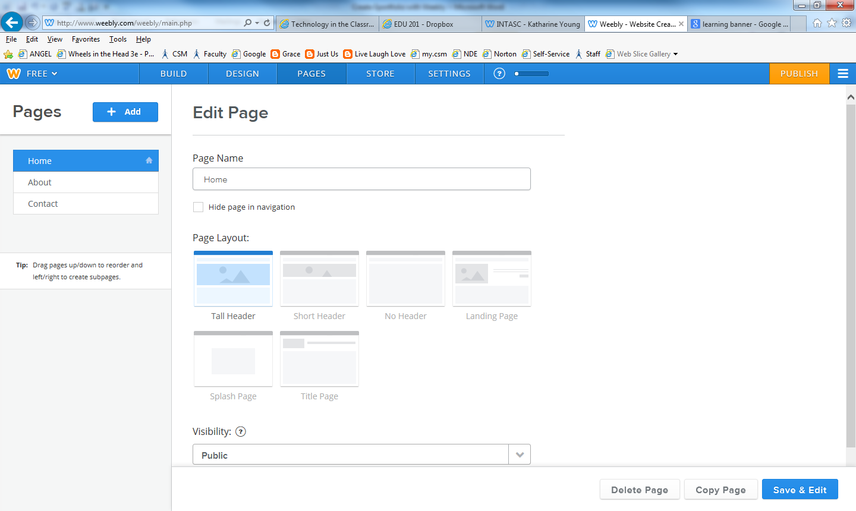

9. **After your design has been selected you are now ready to add pages. The basic structure of your eportfolio includes your homepage, and tabs for technology projects, coursework, resource links, and a tab for your capstone project.**

Go to the “Page” tab to add these pages. Choose Standard Page. “Add Page and Name it. All but the home page should use the Short Header setting. Save settings. If you look on the page tool you will first see your first page titled “Home”. You can click on this page and change it to your name or you may want to leave this as “Home.” You will write your introduction on this page. You can also add favorite quote.

10. Create subpages under the main pages by pulling the tabs under the main pages. See example below.

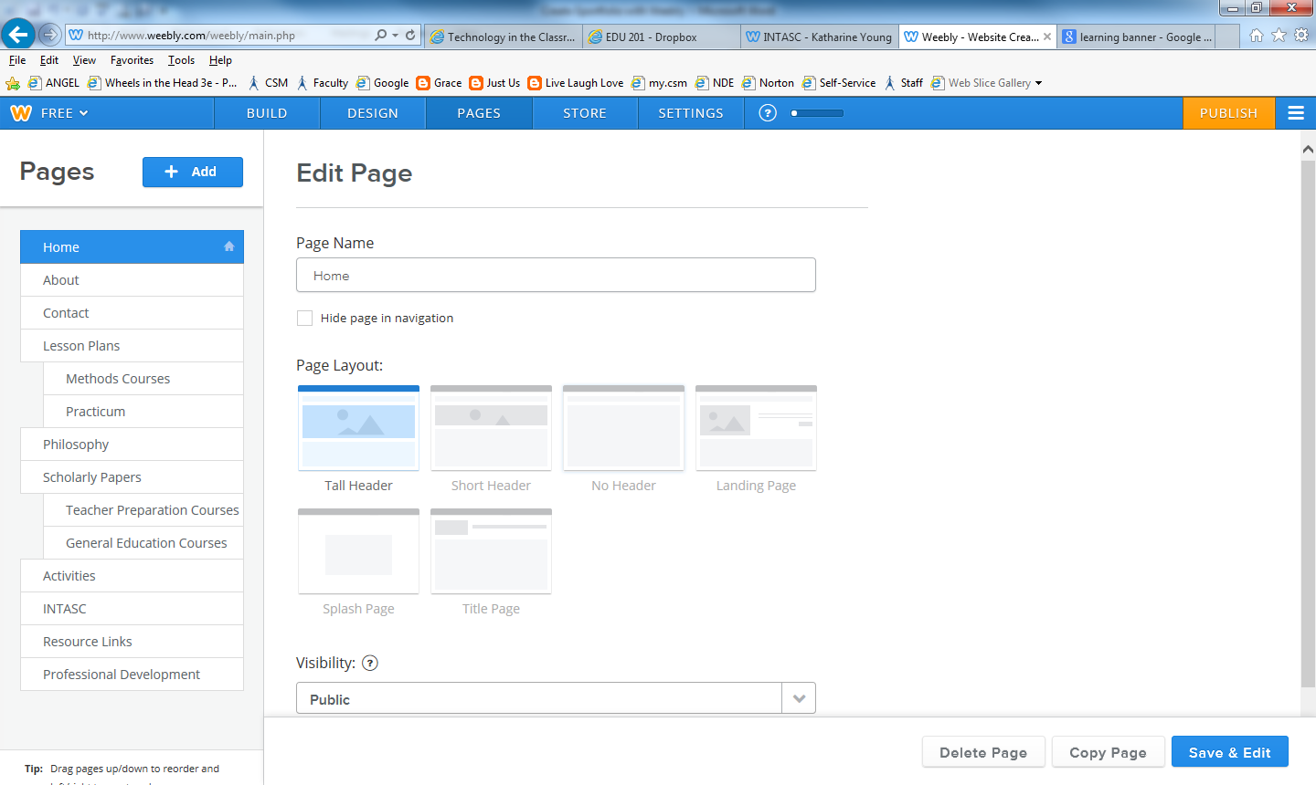

Create the following pages: Technology Projects, Scholarly Work, and Professional Development, Resource Links, and Capstone Project

11. To save your eportfolio, you must publish it by clicking on the button on the upper right.

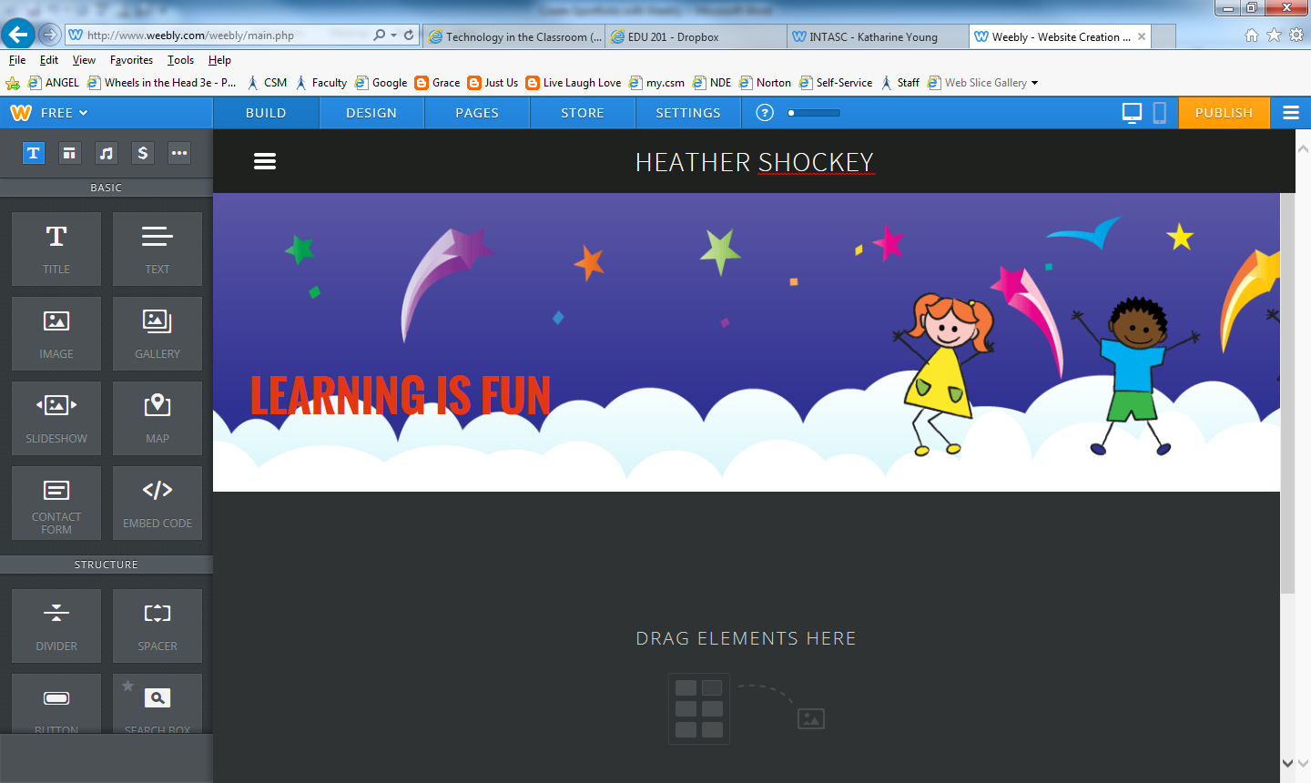

12. After you publish it, it will ask you to select your web-address. It will only do this the first time that you publish it. Remember we are doing the free one. The yellow highlight will be my eportfolio address.

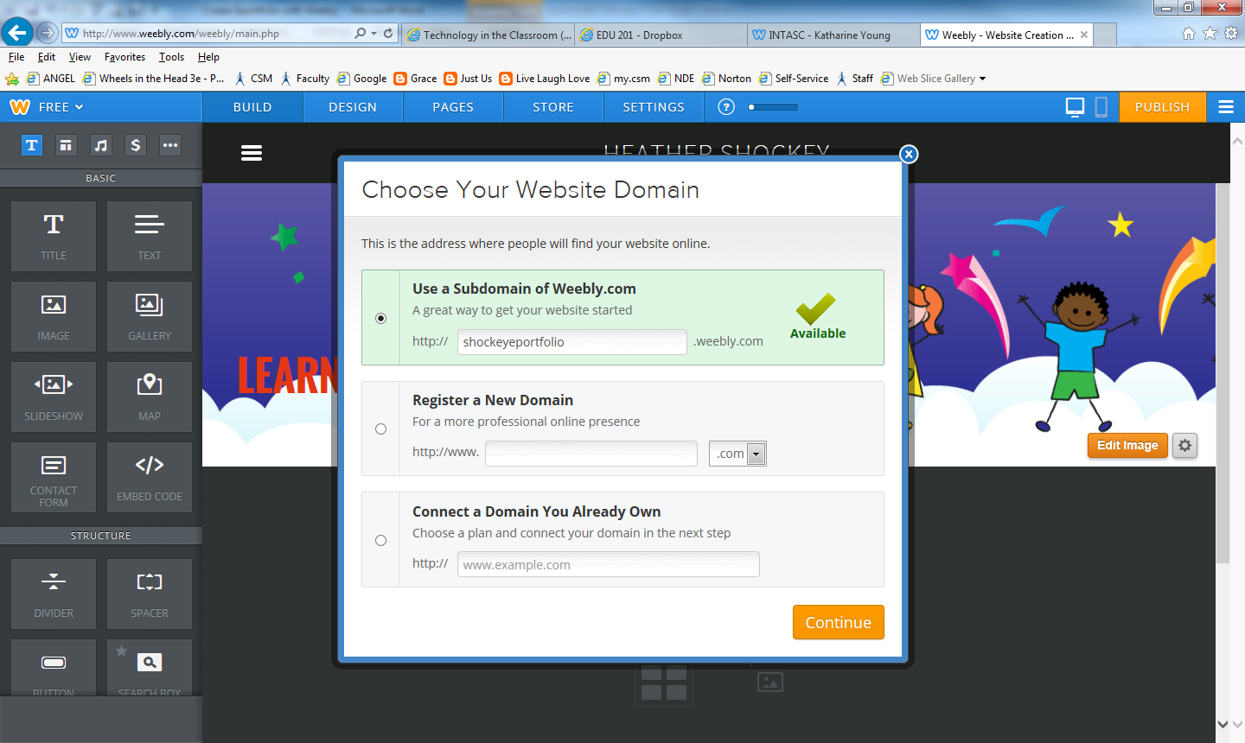

Click Continue

13. This screen shows your eportfolio address. You need to click on this to see the published version. Remember, whenever you submit your eportfolio address, it must be *this one* that has been published as circled in yellow below.

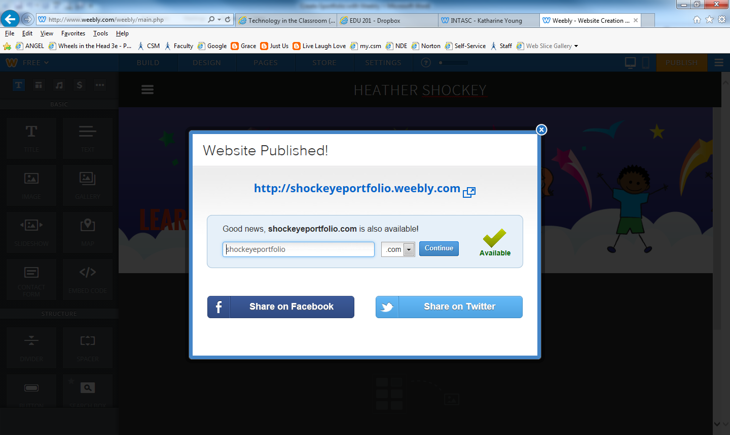

Take a look at your eportfolio on the web now. Do this by right clicking on your URL and clicking on Open in Another Window.

Voila! You are on the World Wide Web.

14. Your published version should look like this. (with your name and theme)

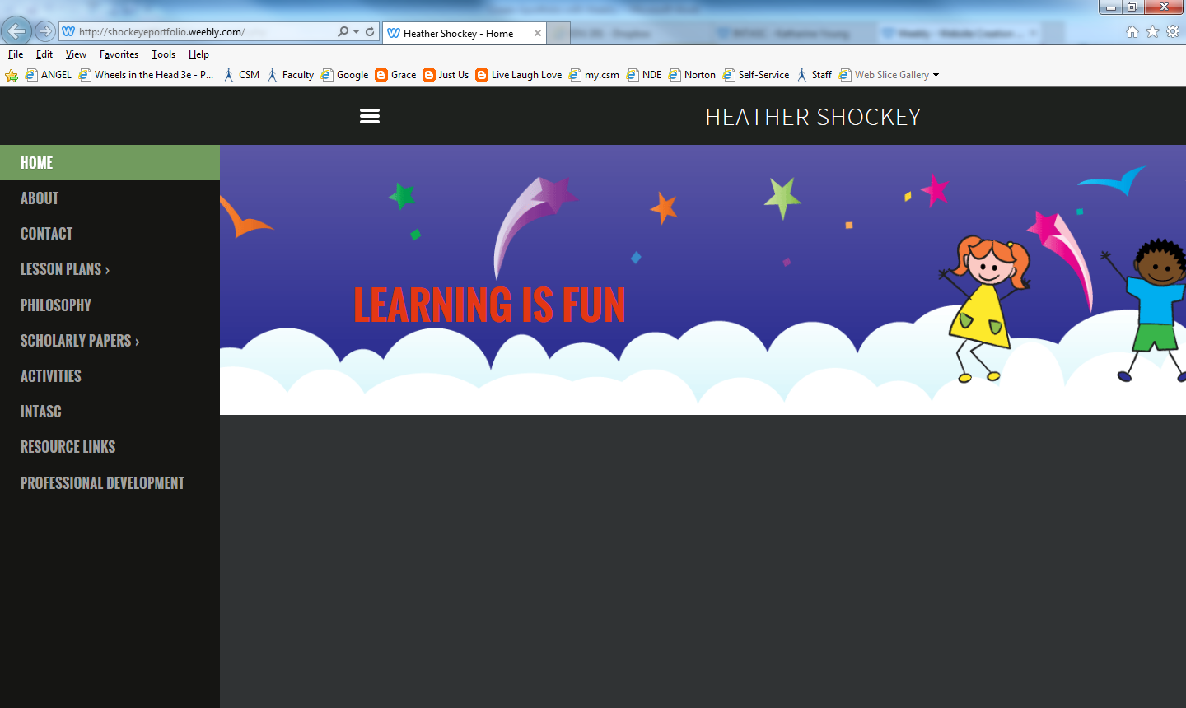

15. To edit your site, log back into <https://education.weebly.com/> and login.

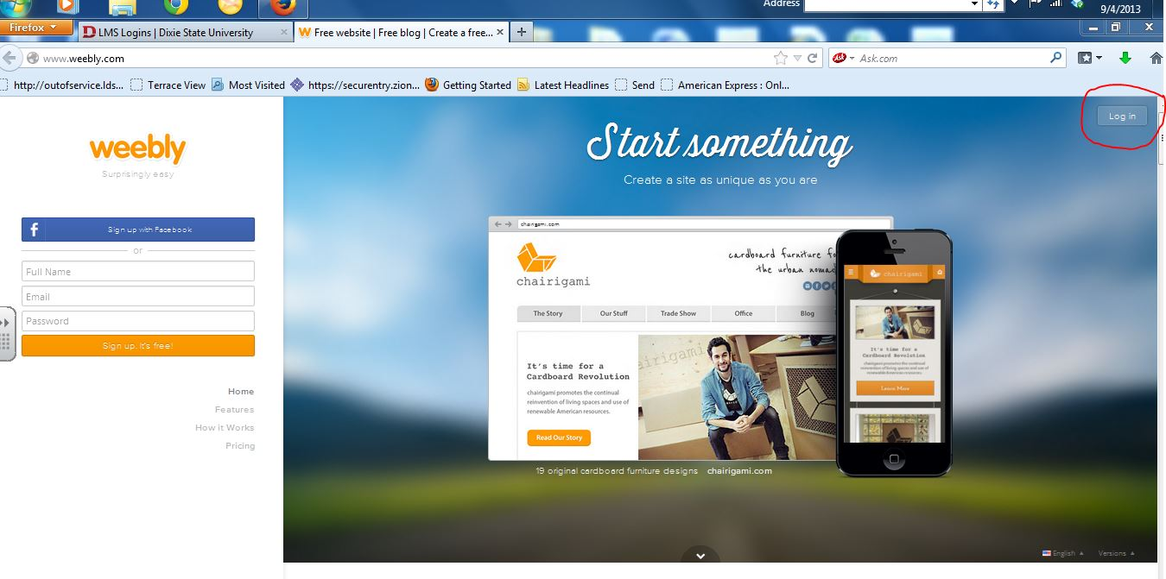

15. You can create a new site or edit an existing site.

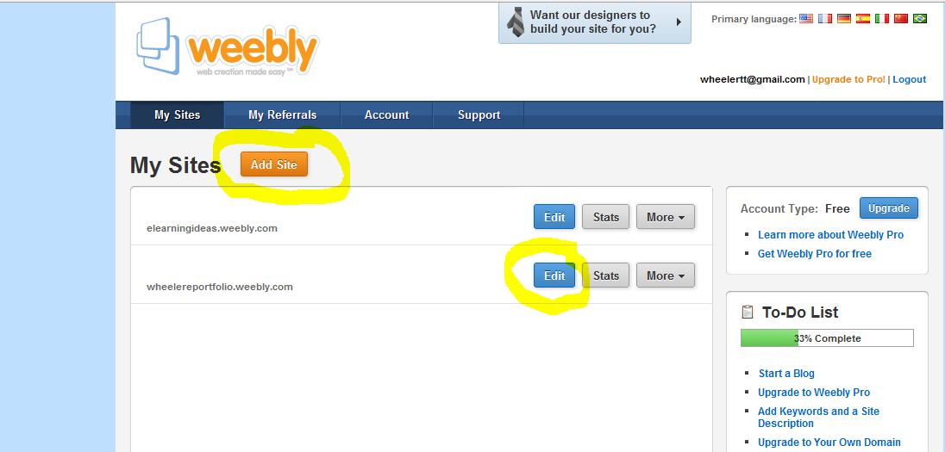

16. Now your portfolio is ready for you to add artifacts (projects, papers, images, video to your eportfolio pages. The tab “Elements” is used to add different media. We will do this late in the course.

17. **For each page** of the eportfolio include a description. Select the “Text” from the Element Tab and drag it onto the page. Write a description of the items in that part of the eportfolio. You will very likely change this as you proceed through the program. Remember to watch spacing; you may have to adjust your text in the webpage. *To delete an element in your web page, just click on it in the edit mode and each should bring up a box with an x in the upper right corner. Click on it and it will ask if you want to delete it.*

19. Copy and paste the URL into the URL Dropbox. I will publish the URLs on my website drmts.com so that you can view each other’s work.