C:\STOCKLAYOUTS\CURRENT PROJECTS\FN99803-PL\FN99803-IMG02.emf

**W 256**

**EDU/ECE 342 342342342342 | |**

**T/R 1:00 - 2:15**

**Dr. Merryellen Towey Schulz**

[**mschulz@csm.edu**](mailto:mschulz@csm.edu)

**402.399-2432**

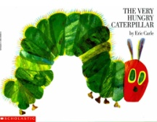

Pleasure

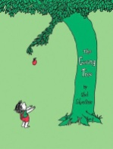

*Children's*

Values

C:\STOCKLAYOUTS\CURRENT PROJECTS\FN99803-PL\FN99803-IMG01.emf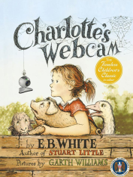

*Literature*

Knowledge

**Course Information**

|  |
| --- |
|  |
|  |

You will interact with a wide variety of children’s literature that is representative of ethnic and cultural diversity. Critical appraisal in light of significant authors and illustrators, quality of writing, and appropriateness of topic to age and/or experience level are emphasized. You will use extensive reading and writing skills, and receive instruction in teaching and guiding students in reading for enjoyment and understanding. Techniques and procedures for promoting life-long reading habits will be explored. A service-learning project is a requirement in this course.

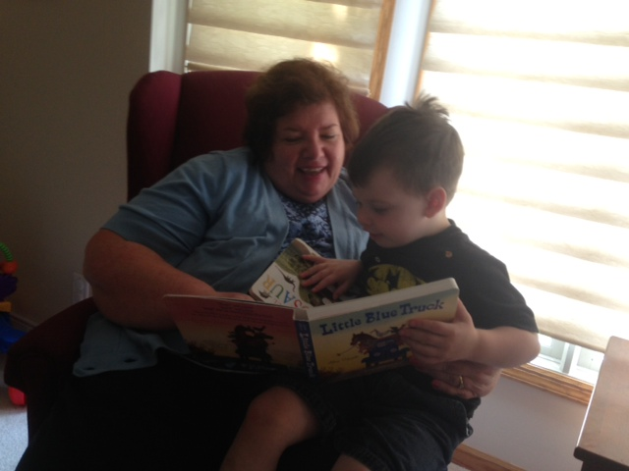

|  |  |
| --- | --- |
| **Classroom Behavior**  Please arrive on time and practice courteous behavior in the classroom. Please do not engage in conversations while someone else is talking or otherwise disrupt class lecture, discussions or activities. Cell phone ringers should be turned off to avoid disruptions and verbal or text communications should not occur during class.  Students should come to class ready to be actively engaged in learning. This includes bringing textbooks, assigned articles, writing materials, notebooks or PowerPoint presentation printouts (if available for the course). Class assignments MUST be submitted on the due date indicated on the course syllabus. Late assignments WILL NOT be graded. Exceptions to this policy will be rare and will be handled on an individual basis.  Courtesy, good time management and collaborative skills are important to success in the work world and should be practiced in the classroom as well. You will be expected to participate in small group activities and be an active team member when working with other students in class.  **Oral and Written Competencies**  Professionals must be able to express themselves adequately in oral and written form. All written work will be evaluated for quality of content and appropriate syntactical structures. Written work that evidences limitations in these areas will be returned for editing and resubmission. Oral expression will also be evaluated and addressed within individual conferences.  **Laptop Usage in the Classroom**  C:\STOCKLAYOUTS\CURRENT PROJECTS\FN99803-PL\FN99803-IMG10.emfLaptop use in classrooms creates new and exciting possibilities for teachers and students when used appropriately. Please use your laptop ethically and for educational purposes and activities permitted by the instructor. Unacceptable uses include: instant messaging, e-mailing, unassigned Internet browsing, game-playing and completing homework for other classes. Violations of this request will result in withdrawal of permission to use the laptop in this class and may affect your grade in the course.  C:\STOCKLAYOUTS\CURRENT PROJECTS\FN99803-PL\FN99803-IMG01.emf | **Academic Honesty**  Plagiarism, defined as the use of another’s words and ideas as one’s own, does not benefit students. It creates dependencies that are non-productive. References must be cited and quotation marks used in direct quotes. Crediting authors with ideas in paraphrasing and rearranging is effective writing. Academic dishonesty includes cheating on exams or quizzes, representing someone else’s work as your own or working jointly on a project that is expected to represent only one student’s original and individual work.  Evidence of plagiarism or academic dishonesty in all institutions carries serious consequences, such as loss of grade and standing. These are serious offenses and will not be tolerated. If a student is guilty of academic dishonesty, it is noted in the student information data base and becomes a part of her academic record and is  Available to advisors and faculty. The complete Academic Honesty Policy is available on the Teacher Education website and in the Teacher Education Handbook.  **Academic Assistance**  In addition to teacher-student conferences and feedback, academic assistance is available within the Achievement Center. Students should become acquainted with these services and seek assistance in areas that would be beneficial for them.  If you have a certifiable learning or physical disability and require special accommodations please call the Achievement Center at 399-2366. Considerable lead time is required for some accommodations so it is important the request received in the Achievement Center ADA office as early in the semester as possible. Please Note: YOUR REQUEST WILL BE HANDLED CONFIDENTIALLY. |

C:\STOCKLAYOUTS\CURRENT PROJECTS\FN99803-PL\FN99803-IMG01.emfC:\STOCKLAYOUTS\CURRENT PROJECTS\FN99803-PL\FN99803-IMG10.emf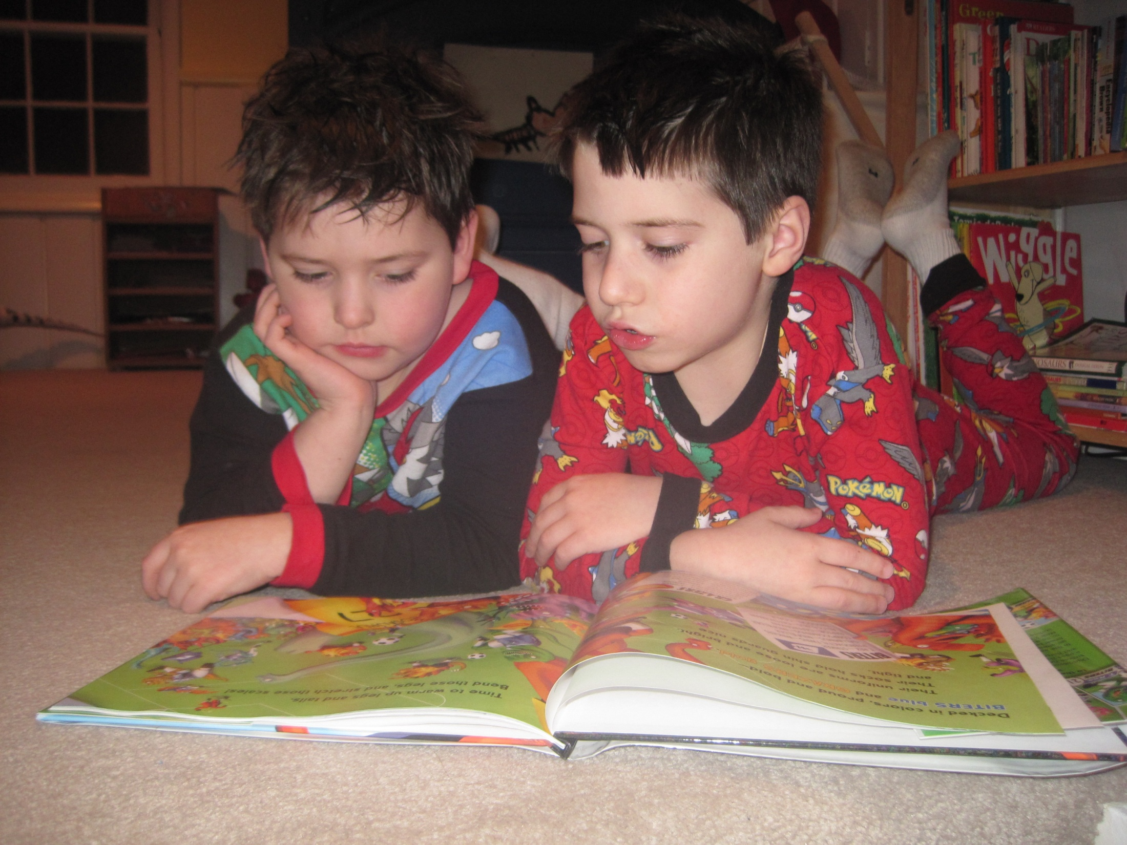

**Tests**

Two periodic exams and a final will be given. Students completing one of the Final

Paper Options will **NOT** be required to take the Final Exam. Student who **DO**

**NOT** complete one of the Paper Options **WILL BE REQUIRED** to take the Final Exam.

**Class Activities** will provide many opportunities to explore and apply theory and content presented through readings and other media on the course web site. These include: Class lectures, discussions, projects and demonstrations,

videos, flannel board stories, social stories, storytelling or other media as appropriate. You will use both familiar and new technologies in completing both in-class and out of class assignments.

**Grading**

|  |  |
| --- | --- |
| Participation | 20 percent |
| Written Assignments | 45 percent |
| In-Class Project | 5 percent |
| Tests | 15 percent |
| Service Practicum | 15 percent |
| Total | 100 percent |

|  |  |
| --- | --- |
| A | 93%-100% |
| B | 84%-92% |
| C | 70%-83% |
| D | 60%-69% |
| F | <60% |

**Course Requirements**

The specific format will be explained and practiced in class. Please feel free to review books discussed in other classes, i.e. Informational Books, Biographies or Historical Fiction from Teaching Natural & Social Science.

Record of Books must include a minimum of 50 books.

Requirements for each major category are:

10 Picture Books

7 Traditional Literature (Folk, fairy tales, fables, etc.)

5 Contemporary Realistic Fiction (Intermediate age)

5 Modern Fantasy & Science Fiction

3 Historical Fiction

3 Biography

7 Poetry

7 Informational Books

2 Books about using literature

1 Audiovisuals*

**Written Assignments**

Design an integrated unit based upon a book that you select.

**Reflection Papers** in response to each service learning visit.

**Presentation** on topic or genre as assigned by instructor.

**Final Project**

You will choose from the following options:

Author Paper

Issue Paper

Write a Children's Book

*(An outline of the story* *including plot, setting and character description must be submitted by midterm in order to select this option.)*

**Service Learning Practicum**

20 hours of at Crestridge International Studies Magnet School. You and your cooperating teacher will determine what you will do for the practicum and service.

**Quizzes & In-Class Work**

Throughout the semester, we will have brief in-class assignments which will be used to assess student

participation. Assignments might include reading quizzes, writing, group work, a summary, a drawing, or a discussion role. These brief, low-stakes assignments serve several instructional purposes, some of which include checking for

understanding, on-going dialogue between members of the course, and analysis and application of course

material. Participation assignments may not be made up due to absences.

**Readings**

While there is not a single textbook required for this course, you will read many articles and books. You will be responsible for reading articles on theory and content which will be posted on ANGEL You will also read many children's books and begin your own classroom library

**Record of Children’s Books:**

Wide reading of children’s books for knowledge and appreciation of books, authors, illustrators from each of the genres of books is required.

A record of your reading and evaluation of books read will be a requirement of this course. You will post this record to a Pinterest page.